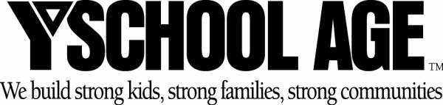

_______ My student will attend the Before Care program at McIntosh Middle School. Please have $45.00 taken from my EFT/CC account on August 15, 2006. Remaining drafts of $39.00 will deducted on the 1st and 15th of each month and ending 5/15/07.

- EFT amount is based on a $4.15 daily before-school fee.
- Before-school hours for McIntosh Middle School are from 7:45am until 9:20am.
- A non-refundable $45.00 registration fee for the first student and $10.00 for each additional student must accompany this form.
- Completed Enrollment Packet, including EFT authorization, are required.
- Failure to meet the chosen payment obligation will result in program termination.
- All program terminations must be submitted in writing 10 working days prior to the bank draft date.
- You MUST escort your student to the before-care program and sign him/her in everyday that your student attends the program.

STUDENT NAME (S)

__________________________________ ________________________
PARENT SIGNATURE DATE

__________________________________
PARENT NAME (PLEASE PRINT)

